ACKNOWLEDGEMENT

It is with great respect and appreciation that we acknowledge the contributions of individuals and institutions who have supported the successful completion of our project, “IOT BASED SMART ROBOT CLEANER”
We are profoundly grateful to our guide, Dr. R. K. Moje, for his exceptional mentorship, technical expertise, and insightful perspectives that played a pivotal role in every stage of this project. His unwavering support and professional guidance significantly enhanced the depth and quality of our work.
We are also very thankful to our respected H.O.D. Dr. D. O. Patil, for providing us with adequate facilities, ways and means by which I was able to complete this project report. We would like to thank our respected Principal Dr. R. V. Patil who creates a healthy environment for all of us to learn in best possible way. We express our thankfulness to all teachers and staff of ENTC department for timely help in course of project report. Finally, special thanks to my friends, family members and all others those unseen people across the internet for maintaining source on the internet that helped us in the successful completion of this work.

ABSTRACT

The rapid advancement of automation and Internet of Things (IoT) technologies has significantly transformed modern living by enhancing convenience, efficiency, and smart control systems. This project presents the design and development of an IoT-Based Smart Robot Cleaner, an intelligent autonomous system capable of performing cleaning tasks with minimal human intervention. The primary objective of this project is to develop a cost-effective, efficient, and user-friendly robotic cleaning solution that can be remotely monitored and controlled using IoT technology.

The proposed system integrates a microcontroller-based architecture (such as Arduino/ESP8266/ESP32) with various sensors, including ultrasonic sensors for obstacle detection, IR sensors for edge detection, and motor drivers for movement control. The robot is equipped with cleaning mechanisms such as rotating brushes and a suction module to effectively remove dust and debris from surfaces. The IoT functionality enables real-time communication between the robot and the user through a mobile application or web interface, allowing users to start, stop, and monitor the cleaning process remotely.

Additionally, the system can provide live status updates, including battery level, cleaning progress, and obstacle alerts, enhancing user interaction and system reliability. The robot follows predefined navigation logic and can adapt to its environment by avoiding obstacles and optimizing its cleaning path. This makes it suitable for use in homes, offices, and small commercial spaces.

The implementation of this project demonstrates how IoT can be effectively utilized to automate routine household tasks, reduce human effort, and improve efficiency. The developed smart robot cleaner offers a scalable and customizable solution that can be further enhanced with advanced features such as AI-based path planning, voice control, and integration with smart home ecosystems.

In conclusion, the IoT-Based Smart Robot Cleaner represents a practical application of embedded systems and IoT technologies, contributing toward the development of smart living environments and autonomous service robots.

Table Of Contents
- INTRODUCTION
  - Introduction about project topic 1
  - Background 2
  - Problem statement 2
  - Literature survey
    - Research Paper 1… 3
    - Research Paper 2… 3

SYSTEM ARCHITECTURE AND DESIGN
  - Architectural Diagram 13-15
  - Methodology 17-18
  - Data Flow Diagram 19

IMPLEMENTATION AND TESTING
  - System Specifications 21-22
  - Testing Strategies 24
  - Algorithms 26

SYSTEM DESCRIPTION & TRAINING
  - System Development and Implementation 28
  - System description 30-33

- RESULTS
  - Project Model 35-36
  - Project Code 37-39
  - Results & Performance 41
  - Project Result 43-45
  - Advantages & Future Scope 47
- CONCLUSION AND REFERENCES
Summary of project findings 49
References 51

List of Figures
Figure NO. 1 – IOT Based Robot Cleaner 3.1
Figure NO. 2 – Block Diagram 3.2
Figure NO. 3 – Methodology Diagram 3.4
Figure NO. 4 – Data Flow Diagram 4.2
Figure No. 5 – ESP32 Microcontroller 5.1
Figure No. 6 – Stages For Proposed Algorithm 5.3
Figure No. 7 – Hardware component of robot cleaner 6.1
Figure No. 8 – IOT based robot cleaner demo 7.4

CHAPTER 1

INTRODUCTION

CHAPTER 1: Introduction

In recent years, rapid advancements in technology have significantly influenced the way daily household tasks are performed. Among these advancements, the integration of robotics and the Internet of Things (IoT) has played a crucial role in developing smart and automated systems that enhance convenience, efficiency, and productivity. One such innovation is the development of intelligent cleaning systems that reduce human effort and improve cleanliness standards. The IoT-Based Smart Robot Cleaner is a modern solution designed to automate the cleaning process using smart technologies and minimal human intervention.

Traditional cleaning methods are often time-consuming, labor-intensive, and inefficient, especially in large areas or environments that require frequent maintenance. While robotic vacuum cleaners are available in the market, they are often expensive and not easily customizable according to user needs. This creates a demand for a cost-effective, flexible, and intelligent cleaning system that can be implemented using readily available components. The proposed project addresses this need by developing a smart robot cleaner that combines embedded systems with IoT capabilities.

The core concept of this project lies in designing an autonomous robot equipped with sensors, microcontrollers, and cleaning mechanisms that can navigate through an environment, detect obstacles, and perform cleaning operations efficiently. The system utilizes a microcontroller such as ESP32, which provides built-in Wi-Fi capability for IoT communication. Through this connectivity, users can remotely monitor and control the robot using a smartphone application or a web-based interface, enabling real-time interaction with the system.

The robot is integrated with various sensors such as ultrasonic sensors for obstacle detection and infrared sensors for edge or cliff detection. These sensors help the robot to move intelligently within its surroundings, avoid collisions, and ensure safe operation. Additionally, the cleaning mechanism, which may include rotating brushes and suction units, is designed to effectively remove dust, dirt, and small debris from the floor surface. The coordinated functioning of hardware and software components ensures smooth operation and efficient cleaning performance.

Another important feature of this system is its ability to provide real-time feedback to the user. Information such as battery status, cleaning progress, and obstacle alerts can be transmitted through the IoT platform, enhancing user experience and system reliability. This level of interaction makes the system more user-friendly and aligns it with modern smart home technologies.

Overall, the IoT-Based Smart Robot Cleaner represents a practical application of automation, embedded systems, and IoT in everyday life. It not only reduces manual effort but also demonstrates how smart technologies can be utilized to create efficient and scalable solutions for household tasks. This project serves as a foundation for further advancements, such as integration with artificial intelligence for improved navigation, voice control systems, and smart home ecosystem compatibility.

To ensure efficient navigation and safe operation, the robot is integrated with multiple sensors. Ultrasonic sensors are used to detect obstacles in the robot's path by measuring the distance to nearby objects, while infrared (IR) sensors help in detecting edges or cliffs, preventing the robot from falling off surfaces such as stairs. These sensors provide continuous feedback to the microcontroller, enabling the robot to make intelligent decisions such as stopping, turning, or changing direction when obstacles are encountered. This autonomous navigation capability is essential for achieving effective cleaning without human intervention.

The cleaning mechanism of the robot typically includes rotating brushes and/or a suction system that collects dust, dirt, and small debris from the floor. The brushes help in loosening dirt particles, while the suction unit ensures proper collection and storage. The combination of mechanical cleaning components with intelligent control enhances the overall performance of the system. Furthermore, the robot is powered by a rechargeable battery, making it portable and convenient for use in different environments.

One of the key features of this project is its IoT integration, which significantly enhances user interaction and system functionality. Through a dedicated mobile application or IoT platform (such as Blynk or a custom web interface), users can send commands to start or stop the robot, control its direction, and monitor its status in real time. Important parameters such as battery level, cleaning progress, and obstacle detection alerts can be displayed to the user, providing a better understanding of the robot's operation. This level of connectivity aligns the system with modern smart home ecosystems, where devices can be controlled remotely and work in coordination with each other.

In addition to its practical applications, this project also serves as an educational platform for understanding the integration of hardware and software in embedded systems. It demonstrates how different components such as sensors, microcontrollers, motor drivers, and communication modules work together to create a functional and intelligent system. The project highlights key concepts such as real- time data processing, control systems, wireless communication, and automation.

In conclusion, the IoT-Based Smart Robot Cleaner represents an effective and economical solution for automated cleaning. It combines the advantages of robotics and IoT to create a smart system capable of performing cleaning tasks efficiently and independently. The project not only reduces human effort but also opens up opportunities for further enhancements, such as the integration of artificial intelligence for advanced navigation, machine learning for adaptive cleaning patterns, voice control through virtual assistants, and automatic docking and charging systems. As technology continues to evolve, such smart robotic systems are expected to play a vital role in shaping the future of home automation and intelligent living environments.

CHAPTER 2

PROBLEM STATMENT

CHAPTER 2. Problem Statement

Cleaning is an essential part of maintaining hygiene and a healthy living environment. However, in today’s fast-paced world, performing regular cleaning tasks manually has become increasingly difficult and time-consuming. Many individuals, especially working professionals and elderly people, find it challenging to dedicate sufficient time and effort to maintain cleanliness in their homes or workplaces. This creates a growing demand for automated systems that can efficiently handle cleaning tasks with minimal human intervention.

While robotic cleaning devices are available in the market, they present several limitations. Most existing solutions are expensive and not affordable for a large section of users. Additionally, these systems are often designed with fixed functionalities, offering limited flexibility and customization according to user requirements. As a result, users are unable to adapt these systems to different environments or specific cleaning needs.
Another major challenge lies in the lack of intelligent navigation and real-time interaction. Many conventional robotic cleaners struggle with obstacle detection, path optimization, and efficient area coverage. They may collide with objects, miss certain areas, or operate inefficiently in complex environments with furniture and dynamic obstacles. Furthermore, several systems do not provide proper remote monitoring or control features, limiting user interaction and reducing overall usability.

CHAPTER 3

LITERATURE SURVEY

CHAPTER 3: Literature Survey

IoT-Based Smart Robot Cleaner
Cleanliness and hygiene are fundamental human needs, and for households, offices, and public spaces, maintaining a clean environment is essential for health and comfort. For individuals with busy schedules, physical limitations, or large spaces to manage, traditional cleaning methods can be time-consuming and inefficient. In recent years, IoT-based smart robot cleaners have emerged as a powerful solution, combining robotics, sensors, and artificial intelligence (AI) to automate cleaning tasks. These systems leverage IoT connectivity to provide intelligent, adaptive, and user-friendly cleaning experiences, significantly improving convenience and quality of life.

Early Developments
In the past, early robotic cleaners were limited to basic programmed movements. These devices relied on simple sensors like infrared or bump detectors to avoid obstacles. While they offered some automation, they often followed rigid cleaning patterns and lacked adaptability. Users had to manually set schedules or control the devices, and the cleaning efficiency was inconsistent. These systems also struggled with complex environments, making them less practical for everyday use.

Evolution with IoT and AI
The integration of IoT and machine learning transformed robotic cleaning technology. With IoT, robot cleaners could connect to smartphones, smart home systems, and cloud platforms, enabling remote monitoring and control. AI algorithms, particularly those based on Simultaneous Localization and Mapping (SLAM), allowed robots to create real-time maps of their environment. This made navigation more accurate and adaptive, ensuring thorough cleaning even in complex spaces.
For example, Zhang et al. (2018) demonstrated how IoT-enabled robot cleaners could use cloud-based data processing to optimize cleaning routes. By analyzing sensor data, the system adjusted its path dynamically, reducing energy consumption and improving coverage. Similarly, Kumar et al. (2019) integrated AI-based obstacle recognition, enabling the robot to distinguish between furniture, walls, and temporary objects like shoes or bags. This improved efficiency and reduced the need for human intervention.

Smart Features
Modern IoT-based robot cleaners offer a wide range of advanced features:
- Remote Control & Monitoring: Users can start, stop, or schedule cleaning sessions via mobile apps or voice assistants.
- Adaptive Cleaning: AI models analyze floor types (tiles, carpet, wood) and adjust suction power or cleaning modes accordingly.
- Data-Driven Optimization: IoT connectivity allows robots to collect usage data, which can be processed to improve performance over time.
- Integration with Smart Homes: Robot cleaners can sync with IoT ecosystems, such as smart lights or thermostats, to operate more efficiently.

Customization and Accessibility
One of the biggest advantages of IoT-based robot cleaners is their customizability and affordability. Traditional cleaning services or advanced industrial robots can be expensive, but IoT-enabled devices are increasingly available at consumer-friendly prices. DIY enthusiasts can even build their own robot cleaners using open-source hardware (Arduino, Raspberry Pi) and software frameworks, making the technology more accessible.

Additionally, these systems are highly adaptable. Users can customize cleaning schedules, define restricted zones, or train the robot to prioritize specific areas. For example, a household with pets can configure the robot to focus on areas prone to fur accumulation. IoT connectivity ensures that these preferences are stored and updated seamlessly, creating a personalized cleaning experience.

Conclusion
IoT-based smart robot cleaners represent a significant leap forward in household automation. By combining robotics, AI, and IoT, these systems provide efficient, adaptive, and user-friendly cleaning solutions. Their affordability, flexibility, and integration with smart home ecosystems make them practical for a wide range of users. As technology continues to evolve, future robot cleaners may become even more autonomous, capable of self-maintenance, and integrated into broader IoT networks, further enhancing convenience and quality of life.

IOT BASED SMART ROBOT CLEANER

Table 1: Research Paper & Methodology
 | SR.  No | Paper Name & Author | Methodology
 | 1 | Smart Robot Cleaner Using Internet of Things  Muhammad Zulhilmi  Hussin1, Jamaludin Jalani2,*, Muhammad Hilmi Powdzi1, Sujana Mohd Rejab3, Mohamad Khairi Ishak4 1 2 3 4 Department of Electrical Engineering Technology, Faculty of Engineering Technology, Universiti Tun Hussein Onn Malaysia, Pagoh Campus, Hab Pendidikan Tinggi Pagoh, M 1, Jalan Panchor, 84600 Panchor, Johor, Malaysia Department of Electronic Engineering, Faculty of Electrical and Electronic Engineering, Universiti Tun Hussein Onn Malaysia, Parit Raja, 86400 Batu Pahat, Johor, Malaysia MyVista, Lot 396, Jalan Matang, 34700 Simpang, Ipoh, Perak, Malaysia Department of Electrical and Computer Engineering, College of Engineering and Information Technology, Ajman University, Ajman, United Arab Emirates | Materials used in this project are Arduino Uno R3, Bluetooth Module HC-05, L293D Motor driver, SG90 RC Servo motor, 12V water pump and Ultrasonic sensor. Meanwhile, the software used in this project is Arduino IDE. (a) Arduino Uno is chosen because the pins required in this project are not more than 13 digital PWM pins.  (b) HC-05 is a Bluetooth module designed to set up a wireless serial connection. It communicates via serial communication, making it simple to interface with a controller or a PC. (c) L293D is a motor driver board that is used to power motors, as the name implies. A single L293D IC can control two DC motors at the same time, and the direction of these two motors can also be controlled independently. (d) An ultrasonic sensor is used to detect the distance between an item and the sensor. (e) SG90 RC is a servo motor that can be controlled by the knob on a rotating angle sensor and can rotate 180 degrees; SG90 RC is used to control the movement of the ultrasonic sensor depending on the detecting an obstacle. (f) A direct current (DC) water pump is a machine that transports or pressurizes liquid. The coil and the commutator rotate when the water pump is on, but the magnetic steel and carbon brushes do not. The commutator and brushes that rotate with the motor change the direction of the coil’s alternating current. The water pump motor gets a signal from the Arduino Uno to channel water from the 1.5L tank to the  mop pad.
 | 2 | INTELLIGENT CLEANING ROBOT USING ARTIFICIAL INTELLIGENCE TECHNOLOGY 1 Ike  Innocent, 2Salla Nelson Stanley, 3Muhammed Abubakar Umar 1,2,3Department of Computer Science Nigerian  Army College of | The development of an Intelligent Cleaning Robot powered by Artificial Intelligence (AI) involves several stages, including hardware design, AI algorithm development, sensor integration, path optimisation, and testing. This research can autonomously navigate and clean indoor environments. It has AI models for object detection, obstacle avoidance, and path planning. This system integrate sensors like ultrasonic, motors, microcontrollers, camera and cleaning  mechanisms, which is developed to control and process software using ROS (Robot Operating

 | Environmental Science and Technology (NACEST) Nasme Makurdi, Benue | System). Our work employs an applied research design with a quantitative and experimental approach. The goal is to design, implement, and evaluate an AI-powered intelligent cleaning robot. The robot was tested in controlled indoor environments (room with varying layouts)
 | Design and Development of | There are many successful products in the market. The leading products are IRobot Roomba, Rrimin Smart Vacuum Cleaners Intelligent Automatic Sweeping Clean Robots, Exilient Ready Maid Robotic Vacuum Cleaner and many more (2). Every product has its own pros and cons. The main problem with these products is they are costly and not much compatible for Indian users (6).
3 | Automatic Cleaning and  Mopping Robot P.S.
 | Adithya1, R. Tejas1, V. Sai
 | Varun1, B.N. Prashanth1
 | 1Department of Mechanical
 | Engineering, Amrita School
 | of Engineering, Bengaluru,
 | Amrita Vishwa
 | Vidyapeetham, India E-mail:
 | bn_prashanth@blr.amrita.ed
 | u

4 | Low Cost Autonomous Robot Cleaner using Mapping Algorithm based on Internet of Things (IoT)  — Rhui Jaan Ong, Ku Nurul Fazira Ku Azir | The paper presents a low-cost autonomous cleaning robot using IoT and mapping algorithms. The robot uses sensors for obstacle detection and navigation. IoT connectivity allows remote monitoring and control. The system focuses on efficient autonomous cleaning with reduced hardware cost.
5 | Autonomous Floor Cleaning Robot — Guruprasad A. M., Anusha, Meghana B. M., Sanjana K. T., Vaishnavi Kumar | This project develops an autonomous floor cleaning robot capable of automatic navigation and obstacle avoidance. The robot uses microcontrollers, sensors, and motor drivers for movement control. The system aims to reduce human effort and improve cleaning efficiency.
6 | Development of an IoT- Based Smart Vacuum Cleaner Controlled via NodeMCU for Autonomous Home Cleaning Solutions — Sumit Kushwaha | The proposed system uses NodeMCU and IoT technology for smart home cleaning applications. The vacuum cleaner performs autonomous cleaning and wireless monitoring through IoT platforms. The system improves user convenience and remote accessibility.
7 | Automatic Obstacle Avoidance Robot using ESP32-CAM as Object Detection Sensor — Gandi Has Muhammad, Yudi Wijanarko | This research focuses on obstacle avoidance using ESP32-CAM for object detection. The robot processes visual data for navigation and movement control. The system demonstrates real-time object detection and autonomous robot movement.

CHAPTER 4

BLOCK DIAGRAM

CHAPTER 4 : Block Diagram
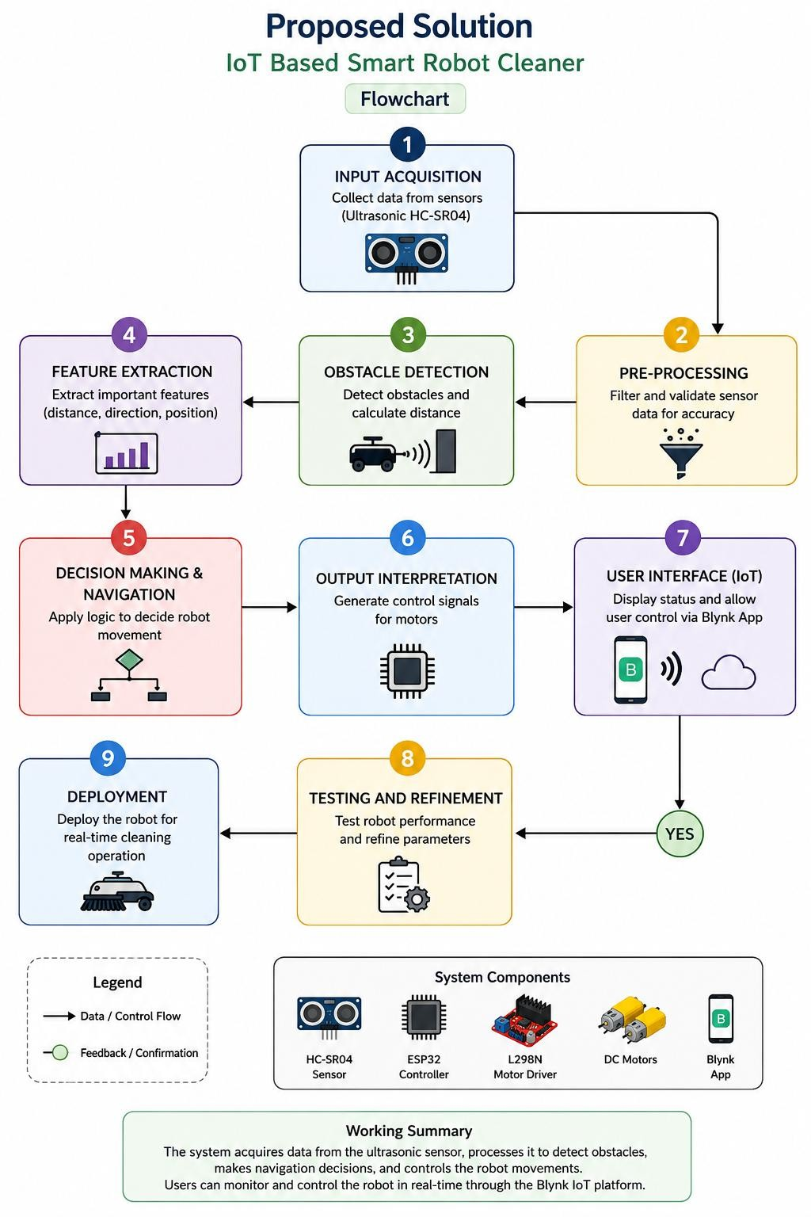
Fig 2: Block Diagram
The proposed IoT Based Smart Robot Cleaner system works by collecting distance data through the HC- SR04 ultrasonic sensor and processing it using the ESP32 microcontroller. The system detects obstacles, makes navigation decisions, and controls the movement of the robot through the motor driver. IoT integration using the Blynk platform enables real-time monitoring and wireless control through a mobile application. The robot performs autonomous cleaning efficiently while avoiding obstacles and maintaining stable operations.

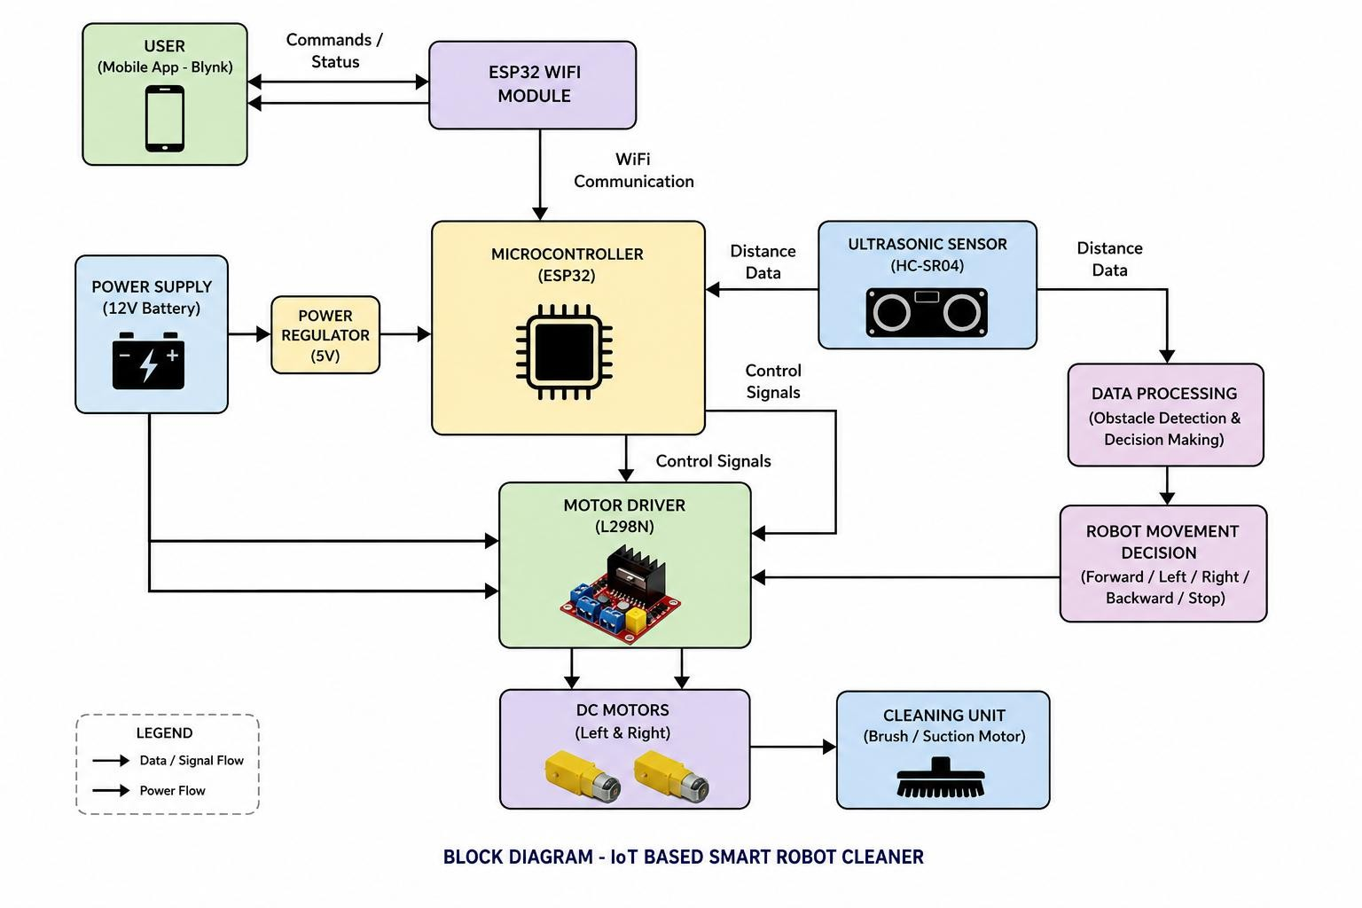

CHAPTER 5

METHODOLOGY

CHAPTER 5 : Methodology
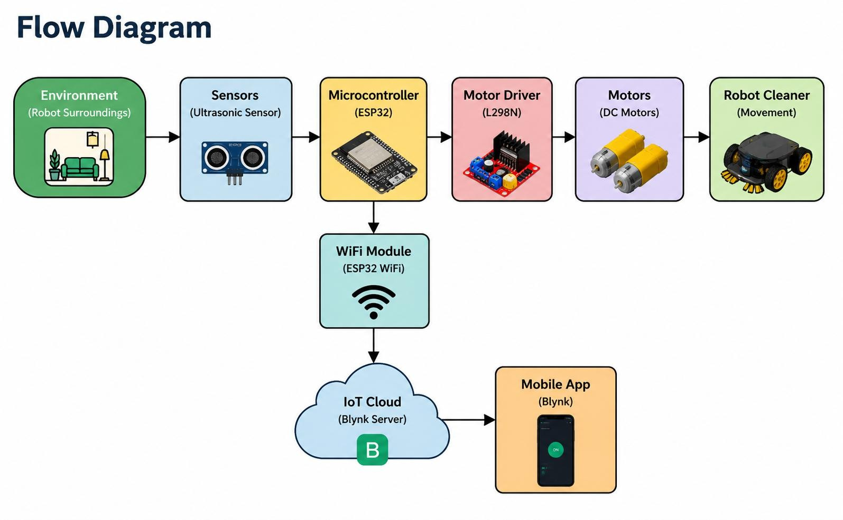
M.B
.C

Fig 3: Methodology

The methodology of the IoT Based Smart Robot Cleaner project involves the design, development, and implementation of an autonomous cleaning robot using IoT technology and embedded systems. The project was completed through the following stages:

➤ System Design

Initially, the overall system architecture was planned, including the selection of hardware components such as ESP32, ultrasonic sensor, motor driver, DC motors, battery, and chassis. A block diagram and circuit diagram were prepared to define the connection and working flow of the system.

➤ Hardware Implementation

All components were mounted on the robot chassis and connected according to the circuit design. The ESP32 microcontroller was used as the central control unit. The ultrasonic sensor was connected for obstacle detection, while the L298N motor driver was interfaced with DC motors for robot movement.

➤ Software Development

Programming was done using the Arduino IDE. The control algorithm was developed to continuously measure obstacle distance using the ultrasonic sensor. Based on the sensor data, the ESP32 controlled the movement of the robot by sending signals to the motor driver.

➤ Obstacle Avoidance Mechanism

The robot continuously monitored the surrounding area using the ultrasonic sensor. If the detected distance was greater than the predefined limit, the robot moved forward. When an obstacle was detected within the threshold distance, the robot stopped and changed direction automatically.

➤ IoT Integration

The ESP32 WiFi module was connected to the Blynk IoT platform for wireless monitoring and control. A mobile application interface was used to control the robot and monitor system operation in real time.

➤ Testing and Performance Evaluation

The complete system was tested in indoor environments to evaluate obstacle detection, motor control, IoT connectivity, and autonomous navigation performance. The robot demonstrated stable operation and successful autonomous cleaning functionality.

Data Flow Diagram
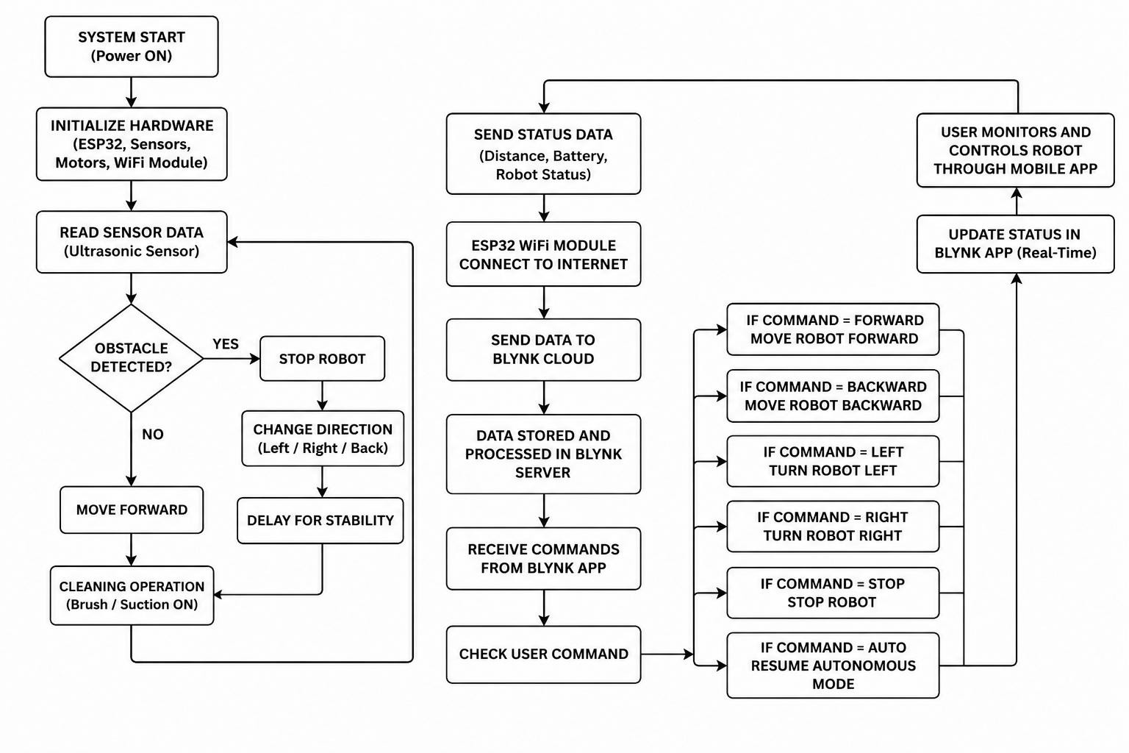

Fig 4: Detailed Flowchart for Proposed Algorithm

CHAPTER 6

SYSTEM SPECIFICATION

CHAPTER 6 : System Specification

Using ESP32 Microcontroller

At first, the ESP32 microcontroller initializes the complete robot system and establishes communication with sensors and IoT modules. The ESP32 continuously receives distance data from the HC-SR04 ultrasonic sensor and processes the input signals to control robot movement. Based on the detected obstacle distance, the ESP32 sends control signals to the L298N motor driver for forward movement, stopping, or changing direction automatically. The ESP32 also connects to the WiFi network for real-time IoT monitoring and mobile control through the Blynk application.
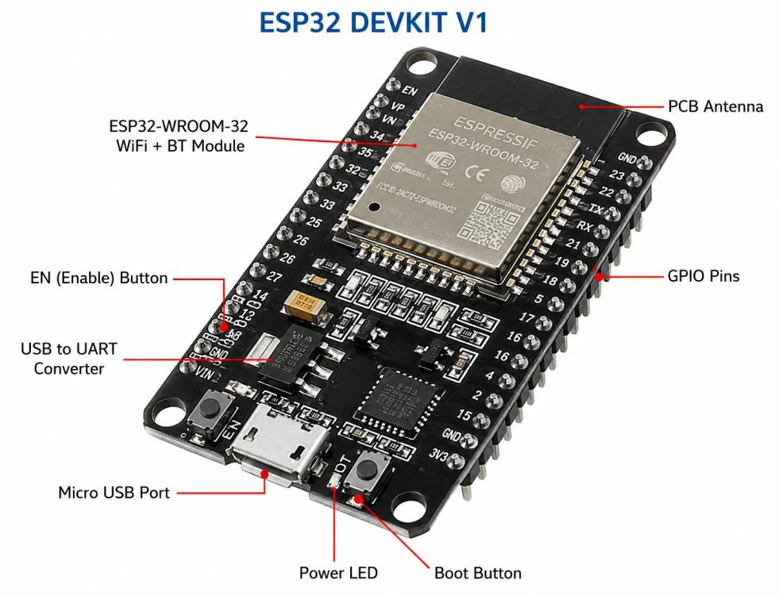

Fig 5: ESP32 Microcontroller

Advantages:

- Low-cost and compact microcontroller with built-in WiFi support.
- Fast processing and real-time obstacle detection capability.
- Supports wireless IoT communication and mobile control.
- Easy programming using Arduino IDE.
- Suitable for embedded systems and robotics applications.

Limitations:

- Limited processing power for advanced AI algorithms.
- Requires stable WiFi connectivity for IoT operation.
- Limited GPIO pins for large-scale hardware expansion.
- Power consumption increases during continuous WiFi usage.

  - Hardware Requirements

Microcontroller | ESP32 WiFi Module for robot control and IoT communication
Ultrasonic Sensor | HC-SR04 for obstacle detection and distance measurement
Motor Driver | L298N Motor Driver Module for controlling DC motors
DC Gear Motors | 2 DC motors for robot movement and navigation
Battery | 12V Li-ion rechargeable battery pack
Power Supply | Rechargeable battery / DC power source

  - Software Requirements

Programming Platform | Arduino IDE
IoT Platform | Blynk IoT Platform
Microcontroller Library | ESP32 Board Package
Mobile Application | Blynk IoT Mobile App
Motor Control Programming | L298N Motor Driver Control Code

CHAPTER 7

TESTING STRATEGIES

CHAPTER 7 : Testing Strategies

Unit Testing
  - Each hardware module such as ESP32, ultrasonic sensor, motor driver, DC motors, and Blynk IoT platform was tested individually.
  - Sensor readings, motor movements, and WiFi connectivity were checked with predefined test conditions to ensure correct operation.

Integration Testing
  - All components were integrated to test the complete robot cleaning system:
    - Ultrasonic Sensor → ESP32 → Motor Driver → DC Motors → Blynk IoT
Verified proper communication between hardware modules without system failure or connection issues.

Functional Testing
  - Tested whether the robot correctly detects obstacles and changes direction automatically
  - Verified autonomous movement, motor control, and IoT functionality.
  - Sample test cases included:
    - " Obstacle detected within 20 cm → Robot stops and turns
    - No obstacle detected → Robot moves forward
    - Mobile command received → Robot responds accordingly

Perfomance Testing
  - System performance was evaluated based on obstacle detection accuracy, motor response, and IoT connectivity.Metrics used: Accuracy, Precision, Recall, F1-Score.
  - Achieved:
    - Reliable obstacle detection using HC-SR04 sensor
    - Stable autonomous movement
    - Smooth wireless control through Blynk IoT platform

Real-Time Testing
  - Tested robot response time from obstacle detection to movement control.
  - The robot responded quickly with minimal delay during navigation.
  - communication.Evaluated under different conditions:
    - Different obstacle distances
    - Indoor floor surfaces
    - Various lighting and environmental conditions

Usability Testing
  - The system was tested for ease of operation and user interaction.
  - Focused on:
    - Simple mobile app control
    - User-friendly autonomous operation

CHAPTER 8

ALGORITHMS

CHAPTER 8 : Algorithms

Obstacle Detection Algorithm
Purpose: Detect Obstacles and Measure Distance
The HC-SR04 ultrasonic sensor is used to detect obstacles in front of the robot by measuring the distance between the robot and nearby objects using ultrasonic waves.
In this system:
  - The ultrasonic sensor continuously transmits ultrasonic pulses.
  - The reflected signal (echo) is received back by the sensor.
  - The ESP32 calculates the distance based on the echo response time.
  - If the detected distance is less than the predefined threshold, the robot stops and changes direction automatically.

- Autonomous Navigation Algorithm Purpose: Robot Movement and Direction Control
The autonomous navigation algorithm controls the movement of the robot based on sensor inputs. It enables the robot to move independently without manual control.
In this system:
  - The ESP32 continuously reads distance values from the ultrasonic sensor.
  - If the path is clear, the robot moves forward.
  - When an obstacle is detected, the ESP32 sends signals to the L298N motor driver.
  - The motor driver controls the DC motors to stop, turn, and continue movement in a different direction.

IoT Communication Algorithm
Purpose: Real-Time Wireless Monitoring and Control
The IoT communication algorithm enables wireless connectivity between the robot and the Blynk IoT platform using the ESP32 WiFi module.
In this system:
  - The ESP32 connects to the WiFi network and Blynk cloud server.
  - Real-time robot status and control commands are exchanged through the mobile application.
  - Users can monitor robot operation and manually control movement remotely.
  - The system provides efficient wireless communication with minimal delay.

CHAPTER 9

System Development and Implementation

CHAPTER 9 : System Development and Implementation

Hardware Setup
The hardware components required for the IoT Based Smart Robot Cleaner were assembled and mounted on the robot chassis. The system was designed using low-cost and easily available electronic components to achieve autonomous cleaning functionality.
The major components used include:
  - ESP32 microcontroller
  - HC-SR04 ultrasonic sensor
  - L298N motor driver
  - DC gear motors
  - Cleaning motor
  - 12V Li-ion battery
  - Robot chassis

The ultrasonic sensor was mounted at the front side of the robot for obstacle detection, while the ESP32 controlled the complete system operation.

Circuit Integration
All hardware modules were connected according to the circuit diagram. The ESP32 microcontroller was interfaced with:
  - Ultrasonic sensor for distance measurement
  - L298N motor driver for motor control
  - WiFi module for IoT communication

Proper power supply connections and grounding were maintained to ensure stable system performance and avoid hardware failures.

Software Development
The robot control program was developed using Arduino IDE and Embedded C programming. The software was designed to:

  - Read distance values from the ultrasonic sensor
  - Detect nearby obstacles
  - Control motor movement automatically
  - Establish IoT communication using Blynk

IoT Integration
The ESP32 WiFi module was connected to the Blynk IoT platform for real-time monitoring and wireless control.
Features implemented:
  - Real-time system monitoring
  - Wireless communication using WiFi
  - Manual and autonomous operation modes

System Testing and Optimization
The developed robot was tested under different indoor conditions to evaluate:
- Obstacle detection accuracy
- Motor control performance
- WiFi connectivity
- Autonomous navigation stability
The system parameters were adjusted and optimized to improve movement efficiency and reduce response delay during obstacle avoidance.

CHAPTER 10

SYSTEM DESCRIPTION

CHAPTER 10: System Description

SYSTEM DESCRIPTION

  - : PROPOSED ALGORITHM VIA SYSTEM DESCRIPION

USE OF ESP32 MICROCONTROLLER

The primary function of this system is to perform autonomous cleaning using obstacle detection and IoT technology. The ESP32 microcontroller acts as the main control unit of the robot. The ultrasonic sensor continuously measures the distance between the robot and nearby obstacles. Based on the sensor data, the ESP32 processes the information and controls the robot movement through the motor driver.
The system also enables wireless monitoring and control using the Blynk IoT platform through WiFi communication.

PREPROCESSING STAGE
The operation of the robot cleaner is divided into three main stages:
- Input Stage
- Processing Stage
- Output Stage

INPUT STAGE

        - The HC-SR04 ultrasonic sensor is used to detect nearby obstacles.
        - The sensor continuously sends and receives ultrasonic waves to measure the obstacle distance.
        - The measured distance data is transferred to the ESP32 microcontroller for further processing.
        - The Blynk IoT application also sends user control commands to the ESP32 through WiFi.

PROCESSING STAGE
The ESP32 performs the main processing and decision-making operations.

        - Major steps performed in this includes:
          - Distance data is received from the ultrasonic sensor.
          - The ESP32 compares the measured distance with the predefined threshold value.

          - If no obstacle is detected, the robot moves forward.
          - If an obstacle is detected within the threshold distance:

            - The robot stops automatically.
            - The robot changes direction to avoid collision.

          - The ESP32 sends control signals to the L298N motor driver for motor movement.

          - Real-time robot status and control data are transmitted to the Blynk IoT platform.

OUTPUT STAGE

- The robot performs autonomous movement and obstacle avoidance.
- The cleaning operation continues automatically without human intervention.
- Real-time monitoring and control are available through the mobile application.
- Robot movement status is displayed on the IoT dashboard.

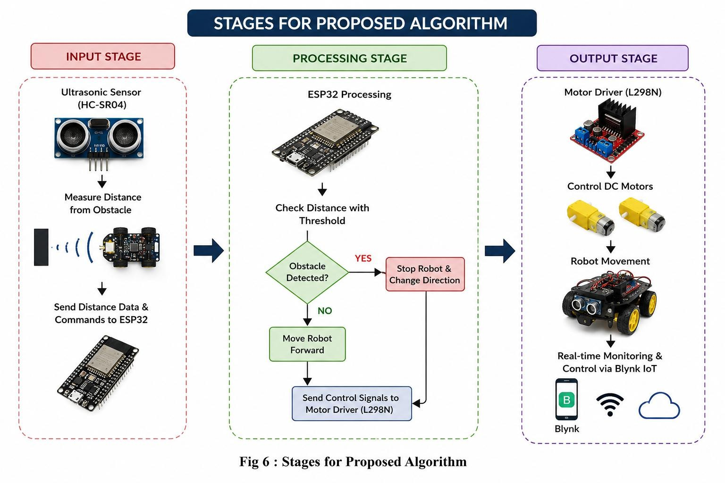

Fig 6 : Stages for Proposed Algorithm.

SYSTEM COMPONENTS

The system consists of various hardware and software components required for autonomous robot cleaning and IoT communication.
Main Components Used:
- ESP32 WiFi Microcontroller
- HC-SR04 Ultrasonic Sensor
- L298N Motor Driver
- DC Gear Motors
- Robot Chassis
- Battery Power Supply
- Blynk IoT Platform

These components work together to achieve obstacle detection, autonomous navigation, and wireless control functionality.

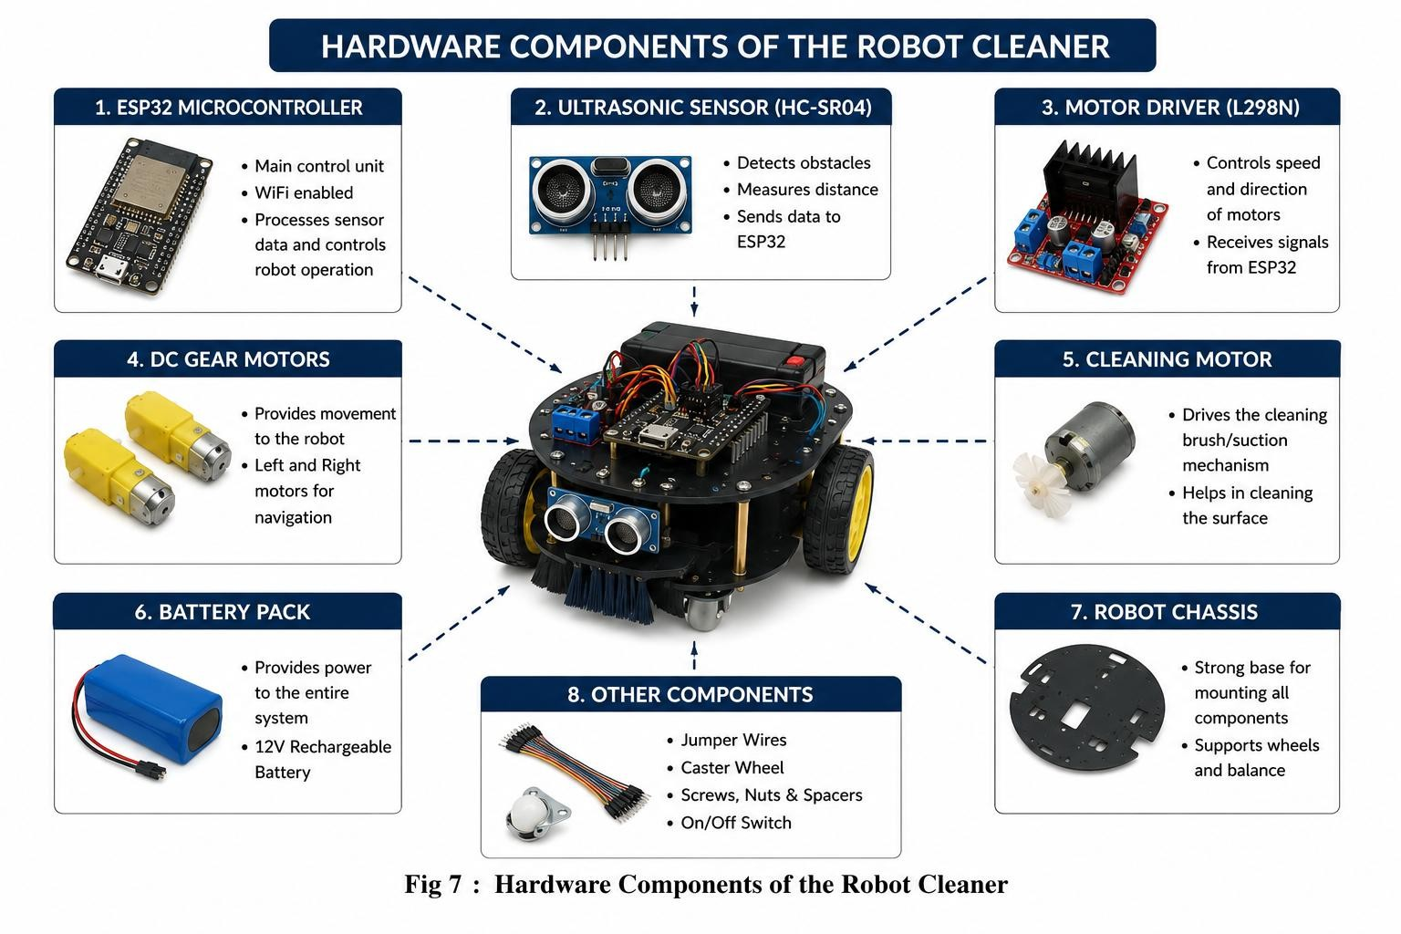

Fig 7 : Hardware Components of the Robot Cleaner

  - BLYNK IoT PLATFORM

Blynk is an IoT platform used for real-time monitoring and wireless control of the robot through a mobile application.
The ESP32 microcontroller connects to the Blynk cloud server using WiFi communication. Users can control robot movement and monitor system operation remotely using the mobile application.

Features of Blynk IoT Platform:
- Wireless robot control
- Real-time monitoring
- User-friendly mobile dashboard
- WiFi-based communication
- Manual and autonomous operation modes

The Blynk platform improves the functionality and flexibility of the robot cleaner system by enabling smart IoT-based control.

CHAPTER 11

PROJECT MODEL

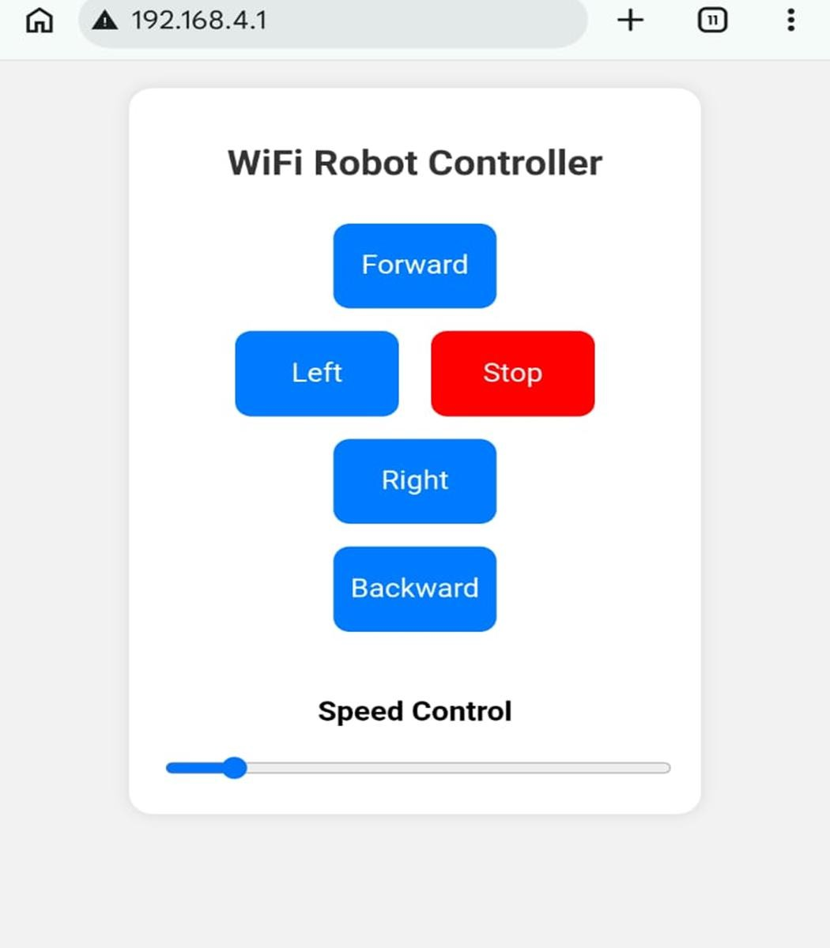

** CODE **
#include <ESP8266WiFi.h> #include <ESP8266WebServer.h>

ESP8266WebServer server(80);

// ================= MOTOR PINS =================
// NodeMCU GPIO Pins #define IN1 D1
#define IN2 D2 #define IN3 D3 #define IN4 D4 #define ENA D5 #define ENB D6

int speedVal = 800; // Speed range: 0–1023
// ================= SETUP =================
void setup() {

pinMode(IN1, OUTPUT); pinMode(IN2, OUTPUT); pinMode(IN3, OUTPUT); pinMode(IN4, OUTPUT);

pinMode(ENA, OUTPUT); pinMode(ENB, OUTPUT);

stopMotor();

analogWrite(ENA, speedVal); analogWrite(ENB, speedVal);

// Create WiFi Hotspot
WiFi.softAP("Robot_Car", "12345678");//192.168.4.1 Serial.begin(115200);
Serial.println();
Serial.println("WiFi Robot Started"); Serial.print("IP Address: "); Serial.println(WiFi.softAPIP());

// Web routes server.on("/", handleRoot);
server.on("/move", handleMove); server.on("/speed", handleSpeed);

server.begin();

Serial.println("Web Server Started");
}

// ================= LOOP =================
void loop() { server.handleClient();
}

// ================= WEB PAGE =================
void handleRoot() {

String html = R"rawliteral(

<!DOCTYPE html>
<html>
<head>

<meta name="viewport" content="width=device-width, initial-scale=1">
<style> body{
font-family: Arial; text-align:center; background:#f2f2f2; margin:0; padding:20px;
}

.container{
max-width:350px; margin:auto;
}

h2{
color:#333;
}
.btn{ width:100px; height:60px; margin:8px; border:none;
border-radius:10px; font-size:18px; background:#007bff; color:white;
}

.btn:active{ background:#0056b3;
}
.stop{ background:red;
}

.slider{ width:100%;
}

.card{ background:white; padding:20px; border-radius:15px;
box-shadow:0px 0px 10px rgba(0,0,0,0.1);
}

</style>

</head>

<body>

<div class="container">

<div class="card">

<h2>WiFi Robot Controller</h2>

<!-- Forward -->
<button class="btn" onmousedown="cmd('F')" onmouseup="cmd('S')" ontouchstart="cmd('F')" ontouchend="cmd('S')"> Forward
</button>
<br>
<!-- Left -->
<button class="btn" onmousedown="cmd('L')" onmouseup="cmd('S')" ontouchstart="cmd('L')" ontouchend="cmd('S')"> Left
</button>

<!-- Stop -->
<button class="btn stop" onclick="cmd('S')"> Stop
</button>

<!-- Right -->
<button class="btn" onmousedown="cmd('R')" onmouseup="cmd('S')" ontouchstart="cmd('R')" ontouchend="cmd('S')">

Right
</button>

<br>

<!-- Backward -->
<button class="btn" onmousedown="cmd('B')" onmouseup="cmd('S')" ontouchstart="cmd('B')" ontouchend="cmd('S')"> Backward
</button>

<br><br>

<h3>Speed Control</h3>

<input type="range" min="0" max="1023" value="800" class="slider"
onchange="setSpeed(this.value)">

</div>

</div>
<script> function cmd(c){
fetch("/move?dir=" + c);
}
function setSpeed(v){ fetch("/speed?val=" + v);
}

</script>

</body>
</html>

)rawliteral";

server.send(200, "text/html", html);
}

// ================= MOVE HANDLER =================
void handleMove() {
String dir = server.arg("dir"); if(dir == "F") {

forward();
}

else if(dir == "B") { backward();
}

else if(dir == "L") { left();
}

else if(dir == "R") { right();
}

else { stopMotor();
}

server.send(200, "text/plain", "OK");
}

// ================= SPEED HANDLER =================
void handleSpeed() {

speedVal = server.arg("val").toInt();

analogWrite(ENA, speedVal); analogWrite(ENB, speedVal);

server.send(200, "text/plain", "Speed Updated");
}
// ================= MOTOR FUNCTIONS =================
void forward() {
digitalWrite(IN1, HIGH); digitalWrite(IN2, LOW);

digitalWrite(IN3, HIGH); digitalWrite(IN4, LOW);
}

void backward() {

digitalWrite(IN1, LOW); digitalWrite(IN2, HIGH);

digitalWrite(IN3, LOW); digitalWrite(IN4, HIGH);
}
void left() { digitalWrite(IN1, LOW);

digitalWrite(IN2, HIGH);

digitalWrite(IN3, HIGH); digitalWrite(IN4, LOW);
}

void right() {

digitalWrite(IN1, HIGH); digitalWrite(IN2, LOW);

digitalWrite(IN3, LOW); digitalWrite(IN4, HIGH);
}

void stopMotor() {

digitalWrite(IN1, LOW); digitalWrite(IN2, LOW);

digitalWrite(IN3, LOW); digitalWrite(IN4, LOW);
}

CHAPTER 12

RESULT & PERFORMANCE

CHAPTER 12 : Results & Performance

Obstacle Detection Accuracy :

The system demonstrated reliable obstacle detection performance using the HC-SR04 ultrasonic sensor. The sensor accurately measured the distance between the robot and nearby objects, allowing the robot to avoid collisions effectively. The ESP32 processed the sensor data efficiently, enabling smooth and quick directional changes during operation. This accurate obstacle avoidance improved the overall autonomous cleaning performance of the robot.

Autonomous Navigation Performance :

The robot successfully achieved autonomous movement with stable motor control and continuous navigation. The L298N motor driver efficiently controlled the DC motors, allowing the robot to move forward, stop, and turn automatically based on sensor inputs. The system maintained smooth operation on flat indoor surfaces and demonstrated reliable movement during repeated testing conditions.

Real-Time IoT Monitoring and Control :

The integration of the ESP32 with the Blynk IoT platform enabled real-time wireless monitoring and control through a mobile application. Users could monitor the robot status and control its movement remotely with minimal delay. The system maintained stable WiFi connectivity and provided efficient real-time communication, making the robot more interactive and user-friendly for smart cleaning applications.

CHAPTER 13

PROJECT RESULTS

im

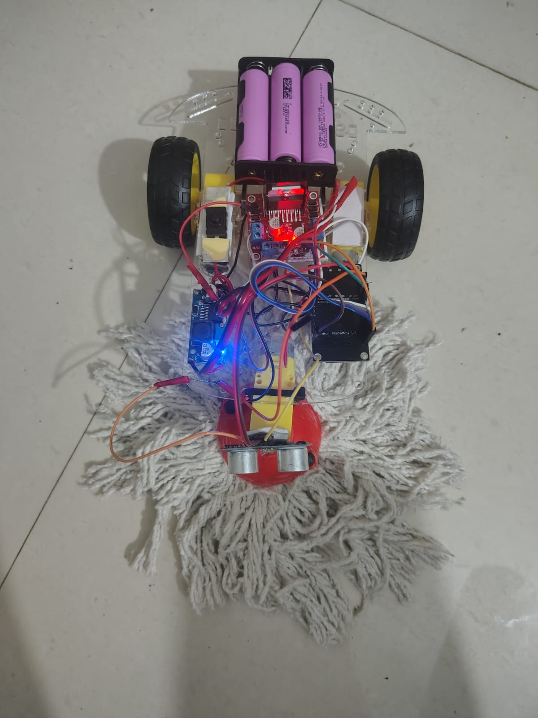

CHAPTER 14
ADVANTAGES & FUTURE SCOPE

Advantage

1. Low Cost Solution
The robot is developed using affordable and easily available components such as ESP32, ultrasonic sensor, and DC motors. Compared to commercial robot cleaners, the overall project cost is significantly lower, making it economical and accessible for students and small-scale applications.

2. Autonomous Cleaning
The robot can move automatically without continuous human intervention. Using the ultrasonic sensor, it detects obstacles and changes direction intelligently, enabling smooth autonomous operation.

3. IoT Enabled System
The integration of ESP32 and Blynk IoT platform allows wireless monitoring and control through a mobile application. Users can monitor robot status and control movement remotely in real-time.

4. Easy to Build and Implement
The hardware design and circuit connections are simple and beginner-friendly. The project can be assembled using basic electronic components and standard programming techniques.

5. Customizable Design
Additional sensors, cameras, vacuum systems, or AI features can be added in the future. The project provides flexibility for further modifications and upgrades.

6. Educational Value
This project helps students gain practical knowledge of:
  - IoT applications
  - Embedded systems
  - Robotics
  - Sensor interfacing
  - Motor control
  - Wireless communication

7. Compact and Portable
The robot has a lightweight and compact structure, making it easy to carry and operate in small indoor environments.

8. Real-Time Monitoring
The IoT dashboard provides live updates about robot operation, connectivity, and system performance, improving user interaction and monitoring capability.

9. Energy Efficient
The robot consumes comparatively low power and operates efficiently using a rechargeable battery system.

10. Foundation for Advanced Robotics
This project can act as a base model for developing advanced autonomous robots using:
  - AI-based navigation
  - SLAM technology
  - Camera vision
  - Smart mapping systems

Future Scope
AI-Based Navigation (SLAM)

Future versions of the robot can use Artificial Intelligence and SLAM (Simultaneous Localization and Mapping) technology for smart navigation and accurate path planning. This will improve obstacle avoidance and cleaning efficiency.

Improved Vacuum Cleaning System

A stronger vacuum mechanism and advanced brush system can be integrated to improve dust collection and cleaning performance on different floor surfaces.

Advanced Mobile Application

The Blynk IoT application can be upgraded with advanced features such as:

  - Real-time mapping
  - Cleaning schedule setup
  - Voice control
  - Battery notifications
  - Area selection for cleaning

Improved Battery Backup

  - Using high-capacity rechargeable batteries can increase operational time and overall efficiency.

CHAPTER 15

CONCLUSION

CHAPTER 15 : Conclusion
The IoT Based Smart Robot Cleaner project was successfully designed and implemented as a low-cost autonomous cleaning solution. The system effectively combines robotics, embedded systems, and IoT technology to perform intelligent cleaning operations with minimal human effort.

The robot is capable of:

  - Detecting obstacles using the ultrasonic sensor
  - Automatically changing direction to avoid collisions
  - Moving autonomously for continuous cleaning
  - Providing remote monitoring and control through the Blynk IoT platform

The integration of the ESP32 microcontroller enabled wireless communication and real-time IoT functionality, making the system smart and user-friendly. The project demonstrated stable performance and efficient operation using affordable and easily available components.

This project also provided practical knowledge and hands-on experience in:

  - IoT systems
  - Sensor interfacing
  - Motor control
  - Embedded programming
  - Robotics applications

Overall, the developed robot cleaner proves that smart automation can be achieved using a simple and economical approach. With future enhancements such as AI-based navigation, advanced mapping, and improved vacuum mechanisms, the system can be further developed into a more intelligent and efficient autonomous cleaning robot suitable for real-world applications.

CHAPTER 16

REFERENCES

CHAPTER 16 : References
- Mohamed A. Alkelsh, Ola A. Bordom, Aya S. Aseid,

“Design & Implementation of an IoT-Based Smart Robotic Vacuum Cleaner for Smart
Home Environment”,
Journal of Technology Research, 2025. (ResearchGate)
- Fahreza Yudhistira, A. M. H. Pardede, Husnul Khair,

“Design and Development of an IoT-Based Room Cleaning Robot”,
Journal of Artificial Intelligence and Engineering Applications (JAIEA), 2025. (IO Informatic)
- Rhui Jaan Ong, Ku Nurul Fazira Ku Azir,

“Low Cost Autonomous Robot Cleaner using Mapping Algorithm based on Internet of Things (IoT)”,
IOP Conference Series: Materials Science and Engineering, 2020. (ResearchGate)
- Guruprasad A. M., Anusha, Meghana B. M., Sanjana K. T., Vaishnavi Kumar,

“Autonomous Floor Cleaning Robot”,
International Journal of Innovative Science and Research Technology (IJISRT), 2025. (Beyond the Box Score)
- Sumit Kushwaha,

“Development of an IoT-Based Smart Vacuum Cleaner Controlled via NodeMCU for
Autonomous Home Cleaning Solutions”,
Journal of Cross-Disciplinary Sustainability Innovations, 2025. (jcdsi.cultechpub.com)
- Gandi Has Muhammad, Yudi Wijanarko,
“Automatic Obstacle Avoidance Robot using ESP32-CAM as Object Detection Sensor”, Jurnal Profesi Insinyur Universitas Lampung, 2025. (jpi.eng.unila.ac.id)
- Ni Luh Ketut Inggitarahayu Anggasemara, I Made Agus Dwi Suarjaya, I Putu Agung Bayupati,

“IoT-Based Vacuum Cleaner Design”,
Walisongo Journal of Information Technology, 2023. (Rajawali)
- Amal Roy, Anandakrishnan S., Basith Rafeeque Mohasin, Chackochan Benny, Mahesh Chakrayudhan, Rizwan M. Shiras,
“ROS-SLAM Powered Autonomous Vacuum Cleaner”, IJFMR Research Journal, 2025. (IJFMR)
- Anh-Tu Nguyen, Cong-Thanh Vu,
“Obstacle Avoidance for Autonomous Mobile Robots Based on Mapping Method”, arXiv Research Paper, 2021. (arXiv)
- Wonse Jo, Jaeeun Kim, Ruiqi Wang, Jeremy Pan, Revanth Krishna Senthilkumaran, Byung-Cheol Min,
“SMARTmBOT: A ROS2-based Low-cost and Open-source Mobile Robot Platform”, arXiv Research Paper, 2022. (arXiv)

